Name:
Tuck Everlasting
USE OF THE ‘WHEEL’ AS A SYMBOL
- Write or draw pictures of as many wheels as you can think of.

- What do you already know about the ‘wheel’?

- Research on the internet or in the library the symbolism of wheels. What did you find?

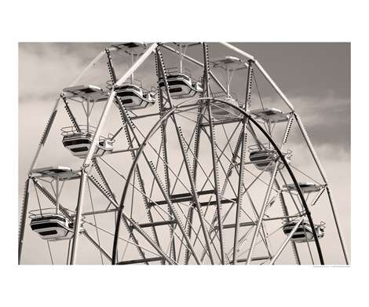
Anticipation Guide
For Tuck Everlasting
By: Natalie Babbit

Directions: Under each question, make a few comments. Discuss which part you agree or disagree with. After reading Tuck Everlasting, mark whether each character agrees or disagrees with each statement.

You Tuck Jesse Winnie
_____ _____ _____ _____ Would immortality be a
blessing or a curse?

_____ _____ _____ _____ Should the natural cycle of
life ever be interrupted or disturbed?

_____ _____ _____ _____ Are we all a part of the
natural cycle of life?

_____ _____ _____ _____ Should death ever be
conquered?

_____ _____ _____ _____ Should life be lived to its
fullest for as long as possible or should we just accept what fate throws our way?

_____ _____ _____ _____ Is the world ready for eternal
life?

_____ _____ _____ _____ If you discovered a fountain
of eternal life, would you hide it, destroy it, share it with the world, or sell bottles of the water at a huge price?

Who’s Who? Most of the characters in Tuck Everlasting are introduced in this section. The main character, Winnie, knows everyone. Write a few words or phrases explaining who each character is, and something about him or her.

Angus Tuck
Miles
man in the yellow suit
Winnie
Mae Tuck
Mrs. Foster
Jesse
Grandmother
Vocabulary Prologue through Chapter Four
Please write the definition of the following words, then illustrate the word by drawing a picture, pasting clipart, magazine image, etc… The fist one is done for you as an example.
Word | Definition | Image
Contemplation p5 | A long and thoughtful observation | 
Infinite p5
Tangent p5
Veer p5
Slack p8

Journal Entry:
If you had the chance to stay young forever, would you take it? Why or why not?
.
Study Guide Questions
Prologue and Chapters 1-8
Review questions prior to reading the chapter, then as you read, complete the questions simultaneously (in complete sentences).

Prologue
- How does the author describe the setting in this section?

- Why do you think she chooses to be so mysterious in the prologue?

Chapter 1
- How does the author’s use of language help you to understand the setting?

- Why aren’t the Fosters curious about the wood? If you were Winnie, do you think you might have wanted to explore the wood? Why or why not?

Chapter 2
- Why does Angus Tuck consider his dream about heaven a “good dream”?

- Why do you think Mae Tuck doesn’t care about her appearance anymore?

Chapter 3
- What do you think Winnie’s life is like? How does it compare to your life?

- Why does Winnie throw stones at the toad? What emotion do you think she is feeling?

Chapter 4
- What is your first impression of the man in the yellow suit? Does the author give you any clues (foreshadow) about his character?

- Where do you think the music that Winnie’s grandmother hears comes from?

Below, draw an image that summarizes the prologue through chapter four.

Vocabulary
Chapters 5-8

Word | Definition | Image
Disheartened p18
Consolingly p19
Elated p35
Recede p35

Journal Entry: Respond to the following quote from the novel, “You can find love, courage, and integrity where you least expect them.”
Study Guide Questions
Chapters 5-8
Chapter 5
- What do you think Jessie is thinking when he tries to prevent Winnie from drinking the spring water?

- What does Mae mean when she says, “The worst is happening at last”?

Chapter 6
- Why do the Tuck’s kidnap Winnie? What do you think you would have done in Winnie’s place?

- Why does Winnie feel reassured when she hears the music box?

Chapter 7
- How had the Tucks figured out they were going to live forever?

- Why do you think the man in the yellow suit is following Winnie and the Tucks?

Chapter 8
- Why does Winnie begin to feel happy about being with the Tucks?

- The man in the yellow suit overhears the Tucks story. What do you think he might be planning? 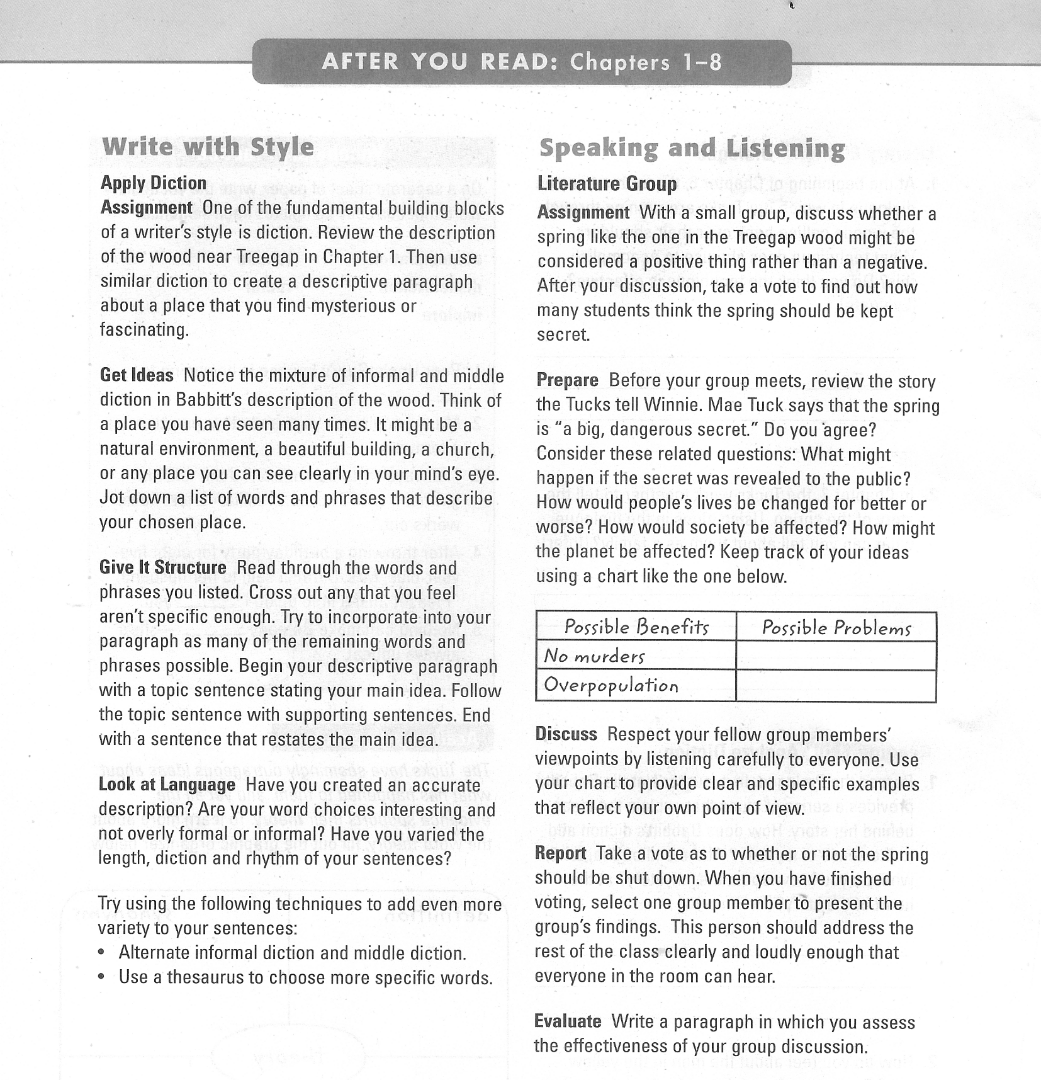
Journal Entry:
What changes in life do you look forward to as you think about growing older?
.
Vocabulary- Chapters 9-12
Word | Definition | Image
Melancholy p38
Submission p39
Perilous p39
Silhouette p48
Anguish p
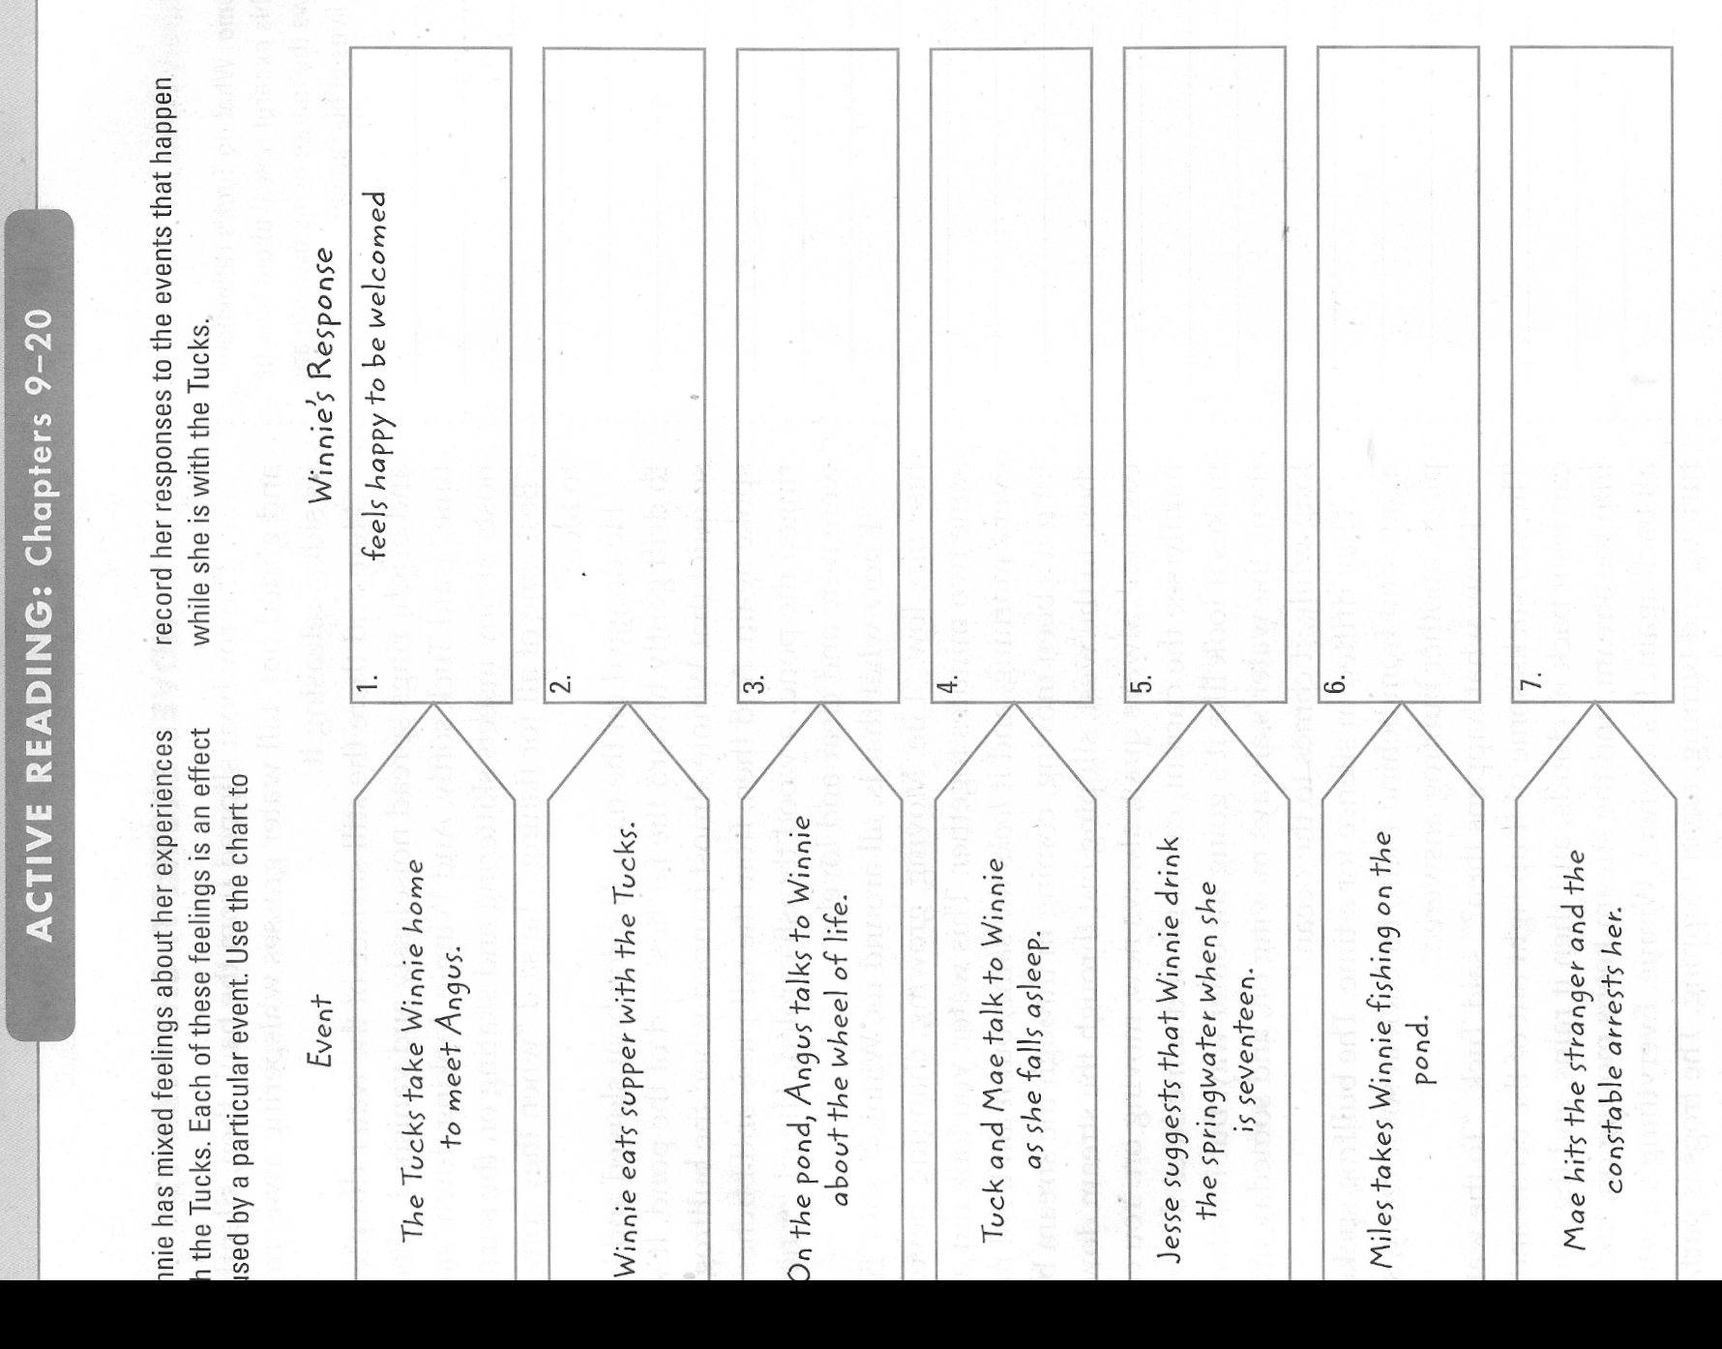
Study Guide- Chapters 9-12
Chapter 9
- It takes many hours for Winnie, Mae, Jesse, and Miles to reach the Tucks’ home. Why do you think they live in such a hard to reach place?

- Why do you think Angus Tuck is so happy to meet Winnie?

Chapter 10
- Do you think Mae thinks of her life as blessed or cursed? Why?

- Why is Winnie so amazed at the inside of Tuck’s home?

Chapter 11
- Why does Winnie suddenly want to go home?

Chapter 12
- Why does Angus Tuck take Winnie to the pond to talk to her?

- How is the movement of the pond water meaningful to their conversation about the cycle of life?
Vocabulary- Chapters 13-16
Word | Definition | Image
Barbarian p57

Gander p61

Study Guide- Chapters 13-16
Chapter 13
- Why do you think the man in the yellow suit goes to the Fosters instead of to the police?

Chapter 14
- Why does Winnie go back and forth, first liking the disorder of the Tucks’ lifestyle, then longing for her regular bedtime routine?

- How do the Tucks make Winnie feel better?

- As Winnie tries to fall asleep, she can’t decide whether or not to believe the Tuck’s story. Would you have believed it? Why or why not?

Chapter 15
- Why do you think the man in the yellow suit wants to trade his knowledge of Winnie’s whereabouts for the Fosters wood?

- What do the man in the yellow suit’s actions tell you about his character?

Chapter 16
- Why is the constable surprised that the Fosters agree to sell the wood?

- Is the constable suspicious of the man in the yellow suit’s motives?

Vocabulary- Chapters 17-20
Create your own vocabulary list. Choose four words from chapters 17-20 and list them below.
Word | Definition | Image
Study Guide- Chapters 17-20
Chapter 17
- How does swatting a mosquito make Winnie realize that dying is a natural part of the life cycle?

- Why does Winnie insist that Miles throw the fish back?

Chapter 18
- Why do you think Miles conceals the reason that he and Winnie return without any fish?

- How have Winnie’s feelings for the Tucks changed? Do you think she has stronger feelings for some of the Tucks than others?

Chapter 19
- Why does the man in the yellow suit see the Tucks as selfish?

- Mae Tuck hits the man over the head with the gun. Do you think she does the right thing? Does she have another option?

Chapter 20
- Why does Winnie lie to the constable?

- Angus Tuck stares at the man in the yellow suit after Maw hits him. What do you think he is thinking about? Why does Winnie seem horrified at Angus Tuck’s reaction?

Vocabulary- Chapters 21- Epilogue
Word | Definition | Image
Exertion p85
Exultant p96
Accomplice p98
Unwittingly p98
Custody p99

Journal Entry: What does it mean to grow up? Are there parts of growing up that are both “satisfying and lonely”?
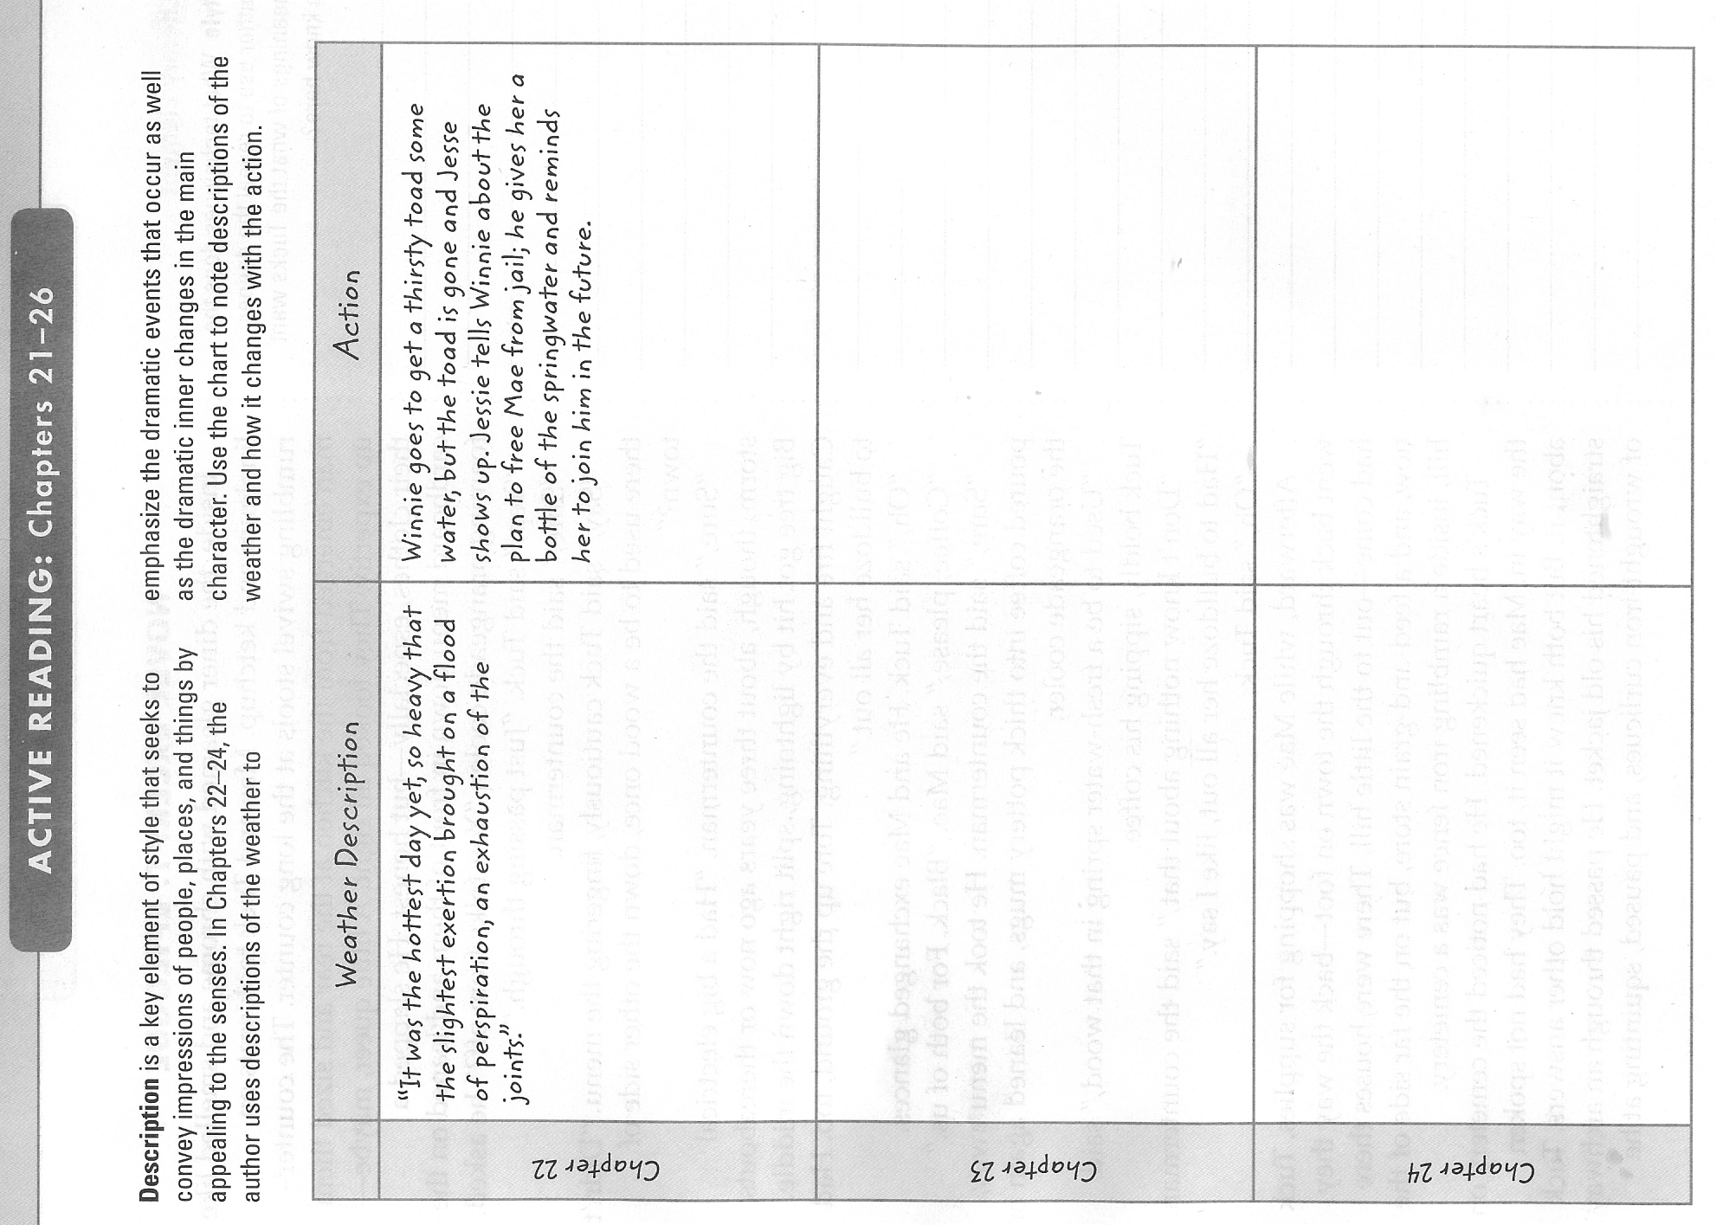
Journal Entry: What are worthwhile goals?
Study Guide- Chapters 21- Epilogue
Chapter 21
- Do you think the Fosters regret selling the wood?

- What makes Winnie’s family think she has changed?

Chapter 22
- Why does Winnie volunteer to help rescue Mae?

- Do you think Jesse should have given Winnie the spring water? Why or why not?

Chapter 23
- Why does being disheveled make Winnie’s mother and grandmother more interesting?

- Why does Winnie feel so good and right about what she is about to do?

Chapter 24
- How do you think Winnie feels helping Mae escape?

- Do you think Winnie does the right thing in freeing Mae? Why?
Explanation writing – Police report
Introduction
At the end of Tuck Everlasting Winnie helps Mae Tuck escape from jail. The constable tells Winnie that this was a criminal act, but that she was too young to be punished by the law. However, the constable would still have had to fill in an official report of the events.
Imagine that you are the constable. Your task is to write the official report about the incidents surrounding the murder of the man in the yellow suit, and the escape of Mae Tuck from prison.
Planning
Use the template below to plan your report. The report should be about 250 words long- use a separate sheet of paper.
Treegap Constabulary.
Crime Record Sheet.

Accused: Recording officer:
Description of event:
Signed: Date:
Notes: These page references will provide important information (supporting evidence) for the report:
pp.72–7 The man in the yellow suit is killed. The constable witnessed the crime.
pp.88–90 Winnie helps Mae escape from jail.
pp. 92–3 Winnie is discovered in the cell.

You might like to use some of the following words in your report:
struck, impact, collapsed, apprehended, restrained, detained, clambered, concealed, surprised
Chapter 25
- How does Winnie’s reputation in the village change after she helps Mae?

- Why do you think Winnie saves the toad from the dog?

- What important decision does Winnie make when she pours the spring water on the toad?

Epilogue
- How does the author connect Winnie and the Tucks at the end of the story?

- Why does Angus Tuck say, “Good girl,” when he sees Winnie’s grave?

Below, draw an image of what Winnie’s gravestone may have looked like, may have said.

Socratic Seminar: Date
As part of your Tuck Everlasting unit exam, you will be participating in a Socratic Seminar.
In effort to be prepared for this class discussion, please contemplate and respond to the following
ideas and quotes, as well as revisit your anticipation guide at the beginning of this packet.

- Winnie decides not to drink the spring water. Why does she make this decision? What has influenced her?

- What, exactly, did the stranger represent in the story?

- Why is it important to understand the story in terms of decisions and consequences?

- What is important about the title?

- How effective is the novel as a fantasy, as it explores immortality?

- Order vs. disorder: what are the ways that the author discusses order and disorder and how do they apply to life?

- Greed: TMITYS feels that money is the most important thing in the world. Do we see examples of this in our current society?

- What is good about death? Does it make us see life differently?

- Did you like the ending? Why? Should it have ended differently? Why?
The Circle Game
Joni Mitchell
©1966
Yesterday a child came out to wonder
Caught a dragonfly inside a jar
Fearful when the sky was full of thunder
And tearful at the falling of a star

Chorus:
And the seasons they go round and round
And the painted ponies go up and down
We’re captive on the carousel of time
We can’t return, we can only look behind
From where we came
And go round and round and round
In the circle game

Then the child moved ten times round the seasons
Skated over ten clear frozen streams
Words like “when you’re older” must appease him
And promises of someday make his dreams

Sixteen springs and sixteen summers gone now
Cartwheels turn to car wheels through the town
And they tell him, “take your time, it won’t be long now”
Till you drag your feet to slow the circles down

So the years spin by and now the boy is twenty
Though his dreams have lost some grandeur coming true
There’ll be new dreams, maybe better dreams and plenty
Before the last revolving year is through

- Which of the characters from Tuck Everlasting could best relate to this song? Why? Why might other characters find it hard to relate to this song?

- On a separate sheet of paper, write at least two additional 4 line stanzas to this song. Decorate the paper appropriately.

The wheel, or cycle, is a recurring theme in the novel Tuck Everlasting. The space below is 1/12 of a circle. You and 11 classmates will join your pieces together to make a whole. As you read the novel, add images, colors, designs, symbols, etc… that reflect your interpretation of the story.

